PROJECT STRUCTURE

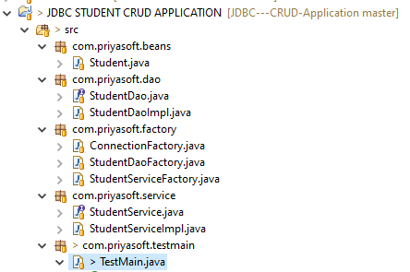

Student.java

**package** com.priyasoft.beans;

**public** **class** Student {

**private** String sid;

**private** String sname;

**private** String saddr;

**public** String getSid() {

**return** sid;

}

**public** **void** setSid(String sid) {

**this**.sid = sid;

}

**public** String getSname() {

**return** sname;

}

**public** **void** setSname(String sname) {

**this**.sname = sname;

}

**public** String getSaddr() {

**return** saddr;

}

**public** **void** setSaddr(String saddr) {

**this**.saddr = saddr;

}

}

StudentDao.java

**package** com.priyasoft.dao;

**import** com.priyasoft.beans.Student;

**public** **interface** StudentDao {

**public** String add(Student std);

**public** Student search(String sid);

**public** String update(Student std);

**public** String delete(String sid);

}

StudentDaoImpl.java

package com.priyasoft.dao;

import java.sql.Connection;

import java.sql.ResultSet;

import java.sql.Statement;

import com.priyasoft.beans.Student;

import com.priyasoft.factory.ConnectionFactory;

public class StudentDaoImpl implements StudentDao {

@Override

public String add(Student std) {

String status="";

try{

Connection con=ConnectionFactory.getConnection();

Statement st=con.createStatement();

ResultSet rs=st.executeQuery("select * from student where SID='"+std.getSid()+"'");

boolean b = rs.next();

if(b==true)

{

status="Student Existed Already";

}else{

int rowCount=st.executeUpdate("insert into student values('"+std.getSid()+"','"+std.getSname()+"','"+std.getSaddr()+"')");

if (rowCount == 1)

{

status="Student insertion success";

}else{

status="student insertion failure";

}

}

}catch(Exception e)

{

e.printStackTrace();

}

return status;

}

ConnectionFactory.java

package com.priyasoft.factory;

import java.sql.Connection;

import java.sql.DriverManager;

public class ConnectionFactory {

private static Connection con;

static{

try{

Class.forName("oracle.jdbc.OracleDriver");

con=DriverManager.getConnection("jdbc:oracle:thin:@localhost:1521:xe","system","admin");

}catch(Exception e)

{

e.printStackTrace();

}

}

public static Connection getConnection(){

return con;

}

}

StudentDaoFactory.java

package com.priyasoft.factory;

import com.priyasoft.dao.StudentDao;

import com.priyasoft.dao.StudentDaoImpl;

public class StudentDaoFactory {

private static StudentDao studentDao;

static{

studentDao=new StudentDaoImpl();

}

public static StudentDao getStudentDao()

{

return studentDao;

}

}

StudentServiceFactory.java

package com.priyasoft.factory;

import com.priyasoft.service.StudentService;

import com.priyasoft.service.StudentServiceImpl;

public class StudentServiceFactory {

private static StudentService studentService;

static{

studentService = new StudentServiceImpl();

}

public static StudentService getStudentService()

{

return studentService;

}

}

StudentService.java

**package** com.priyasoft.service;

**import** com.priyasoft.beans.Student;

**public** **interface** StudentService {

**public** String addStudent(Student sid);

**public** Student searchStudent(String sid);

**public** String updateStudent(Student sid);

**public** String deleteStudent(String sid);

}

StudentServiceImpl.java

package com.priyasoft.service;

import com.priyasoft.beans.Student;

import com.priyasoft.dao.StudentDao;

import com.priyasoft.factory.StudentDaoFactory;

public class StudentServiceImpl implements StudentService {

@Override

public String addStudent(Student std) {

StudentDao studentDao=StudentDaoFactory.getStudentDao();

String status=studentDao.add(std);

return status;

}

@Override

public Student searchStudent(String sid) {

StudentDao studentDao=StudentDaoFactory.getStudentDao();

Student std=studentDao.search(sid);

return std;

}

@Override

public String updateStudent(Student std) {

StudentDao studentDao=StudentDaoFactory.getStudentDao();

String status=studentDao.update(std);

return status;

}

@Override

public String deleteStudent(String sid) {

StudentDao studentDao=StudentDaoFactory.getStudentDao();

String status=studentDao.delete(sid);

return status;

}

}

TestMain.java

package com.priyasoft.testmain;

import java.io.BufferedReader;

import java.io.InputStreamReader;

import com.priyasoft.beans.Student;

import com.priyasoft.factory.StudentServiceFactory;

import com.priyasoft.service.StudentService;

public class TestMain {

public static void main(String[] args) {

try{

BufferedReader br=new BufferedReader(new InputStreamReader(System.in));

while(true)

{

System.out.println();

System.out.println("1. INSERT");

System.out.println("2. RETRIEVE");

System.out.println("3. UPDATE");

System.out.println("4. DELETE");

System.out.println("5. EXIT");

System.out.println("Your Option[1,2,3,4,5]:");

int option=Integer.parseInt(br.readLine());

StudentService studentservice=StudentServiceFactory.getStudentService();

String sid="";

String sname="";

String saddr="";

switch(option)

{

case 1:

System.out.println("Student Id :");

sid=br.readLine();

System.out.println("Student Name :");

sname=br.readLine();

System.out.println("Student Address :");

saddr=br.readLine();

Student std=new Student();

std.setSid(sid);

std.setSname(sname);

std.setSaddr(saddr);

String status= studentservice.addStudent(std);

System.out.println("Status :"+status);

break;

case 2:

System.out.println("Student ID:");

sid =br.readLine();

std=studentservice.searchStudent(sid);

if(std==null)

{

System.out.println("Student not existed.");

}else{

System.out.println("Student Details");

System.out.println("-----------------------------");

System.out.println("Student Id:"+std.getSid());

System.out.println("Student Name:"+std.getSname());

System.out.println("Student Address:"+std.getSaddr());

}

break;

case 3:

System.out.println("Student ID:");

sid=br.readLine();

std=studentservice.searchStudent(sid);

if(std==null)

{

System.out.println("Status: Student Not Existed");

}else{

System.out.println("Student Name[Old Name:"+std.getSname()+"]:");

String sname_New=br.readLine();

if(sname_New == null || sname_New.equals("")){

sname_New=std.getSname();

}

System.out.println("Student Address[Old Address:"+std.getSaddr()+"]:");

String saddr_New=br.readLine();

if(saddr_New == null || saddr_New.equals("")){

saddr_New=std.getSaddr();

}

Student std_new=new Student();

std_new.setSid(sid);

std_new.setSname(sname_New);

std_new.setSaddr(saddr_New);

status=studentservice.updateStudent(std_new);

System.out.println("Status:"+status);

}

break;

case 4:

System.out.println("Student ID:");

sid=br.readLine();

std=studentservice.searchStudent(sid);

if(std==null)

{

System.out.println("Status: Student Not Existed");

}else{

status=studentservice.deleteStudent(sid);

System.out.println("Status:"+status);

}

break;

case 5:

System.out.println("**********************ThankQ for using Student Application***************************************");

System.exit(0);

break;

default:

System.out.println("Provide number from 1,2,3,4,5");

break;

}

}

}catch(Exception e)

{

e.printStackTrace();

}

}

}

OUTPUT: INSERTION

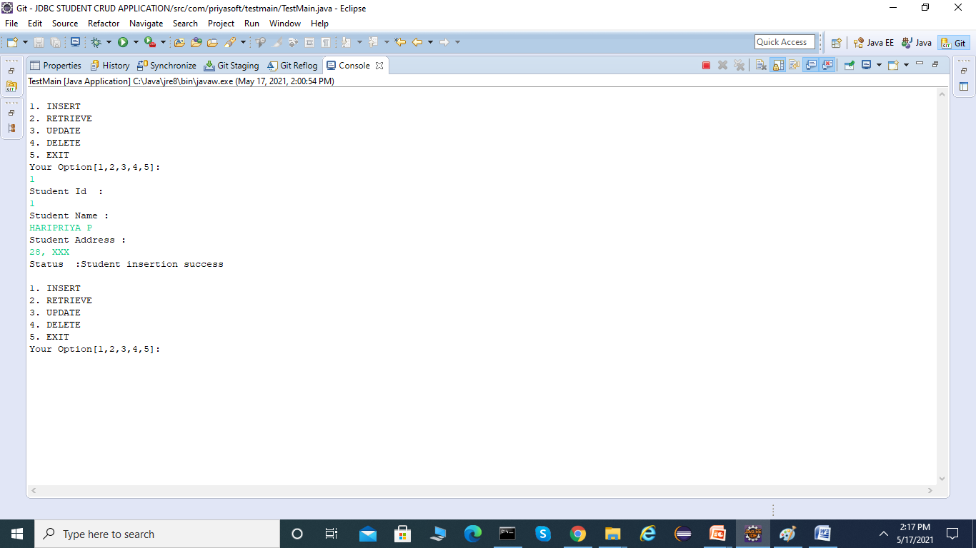

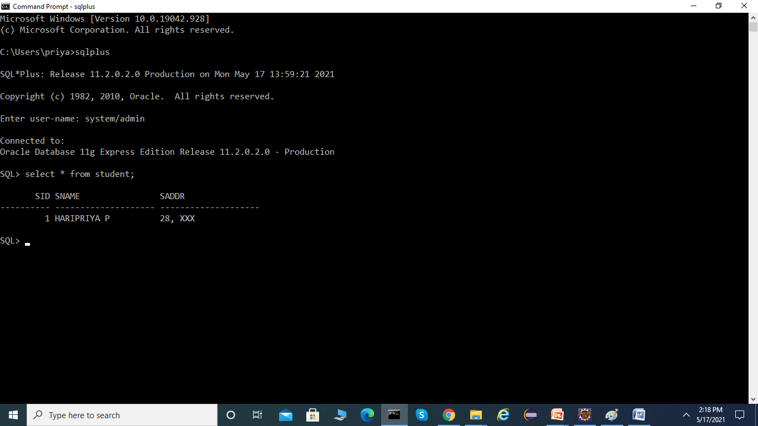

OUTPUT: RETRIEVE

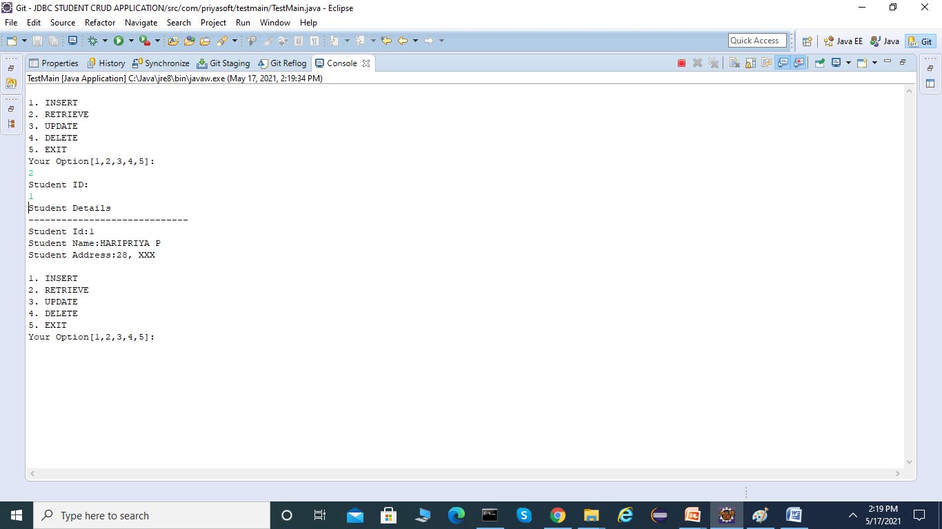

OUTPUT: UPDATE

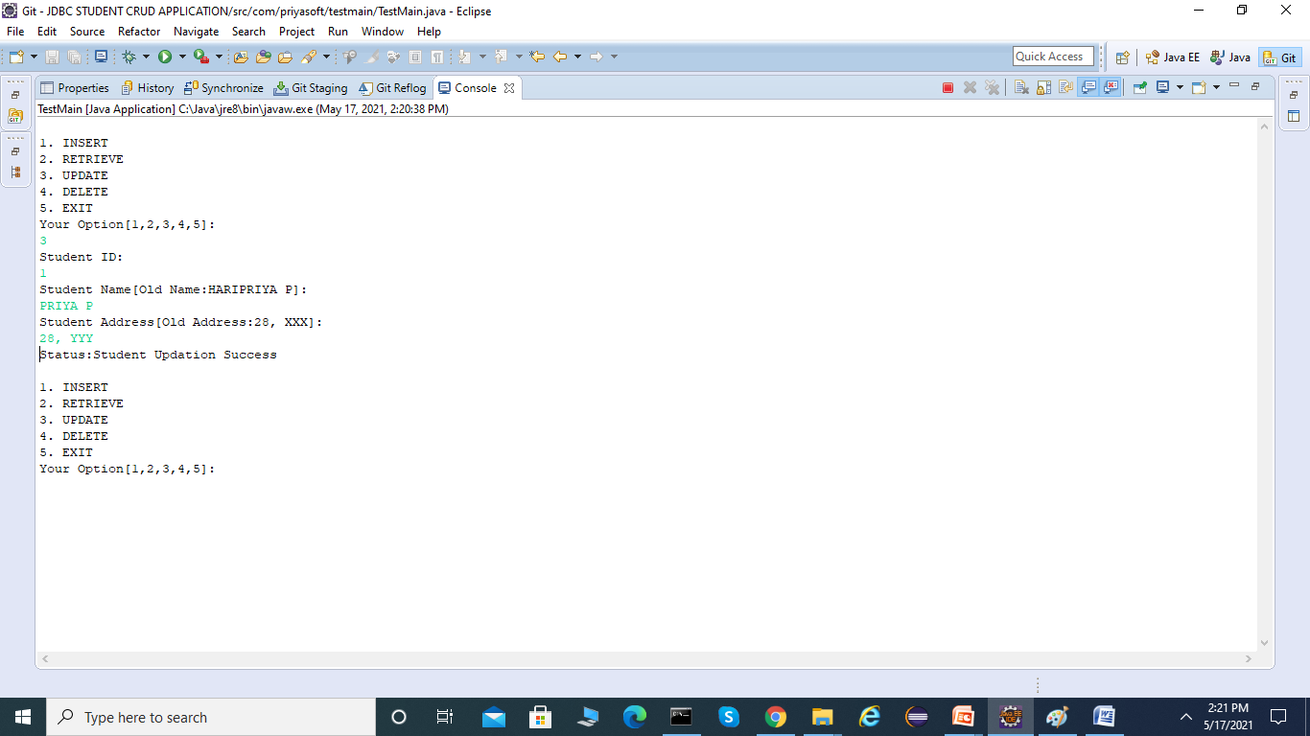

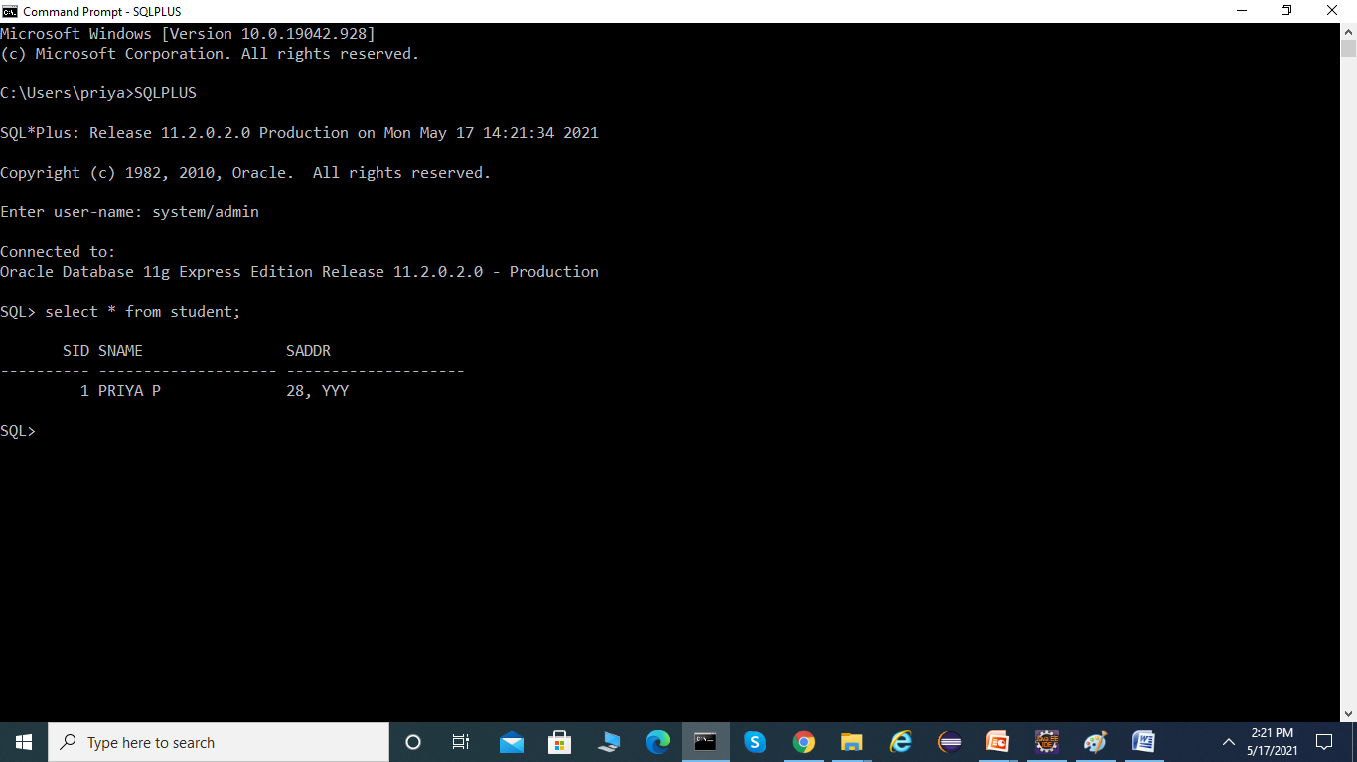

OUTPUT: DELETE

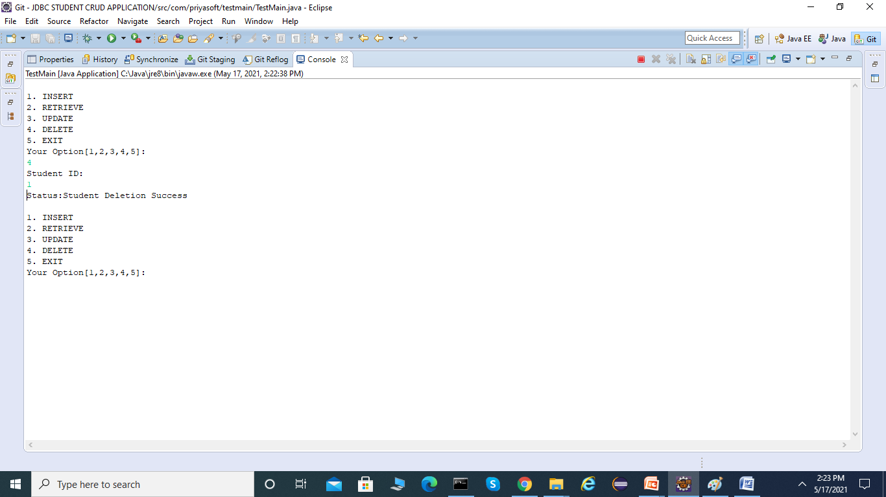

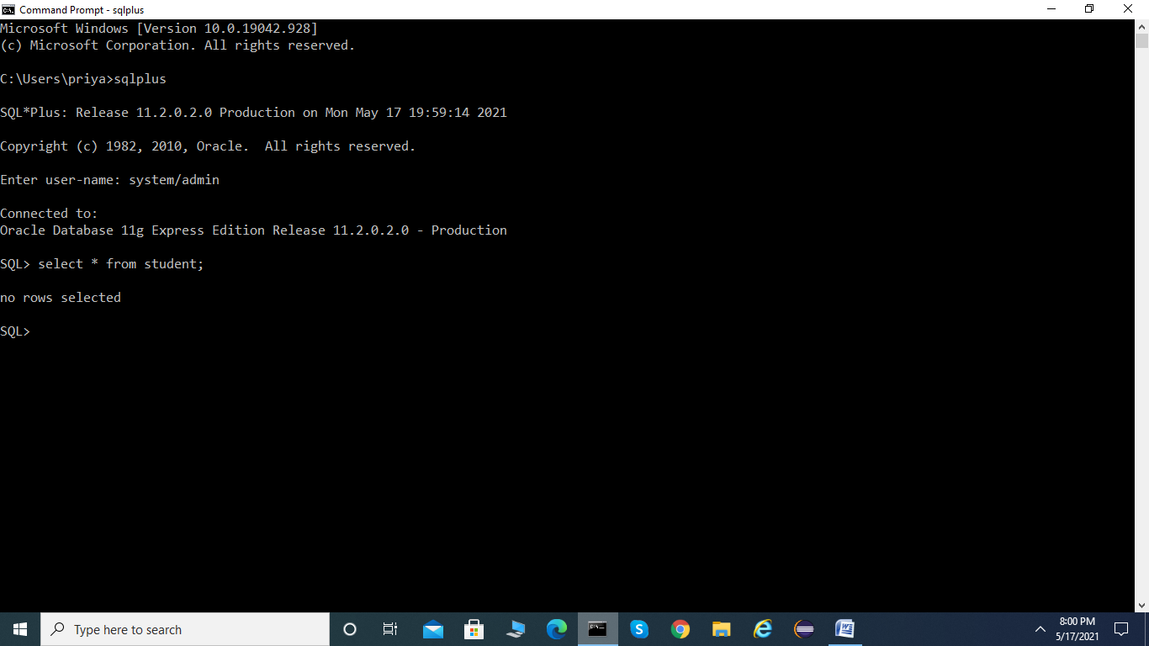

OUTPUT: EXIT

